**Report**

**Q. 1) Find all the unique 'Wind Speed' values in the data.**

Ans:- Total 34 unique “Wind Speed” values are there in the data.

Proof:-

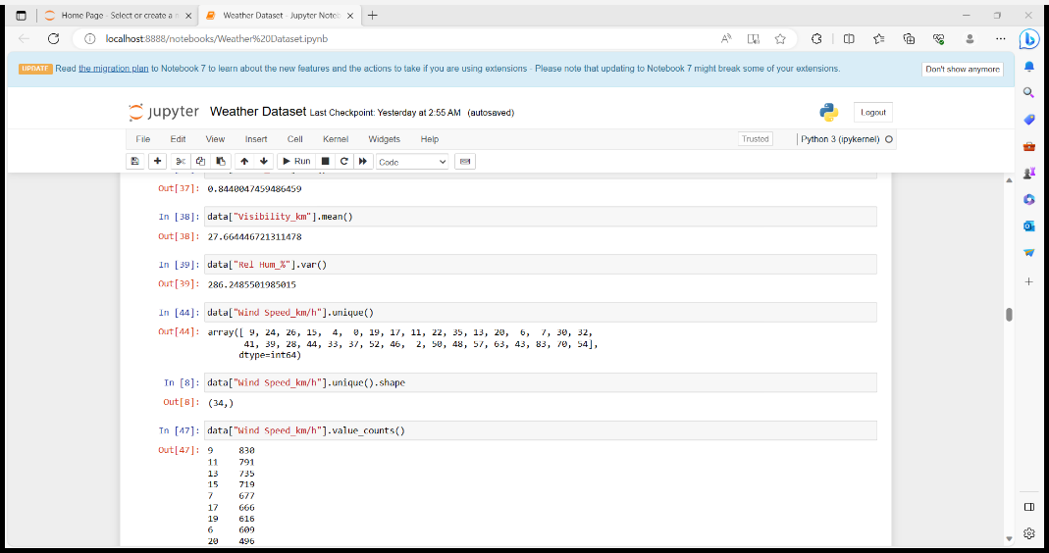

**Q. 2) Find the number of times when the 'Weather is exactly Clear'.**

Ans:- Total 1326 times the Weather is exactly clear.

Proof:-

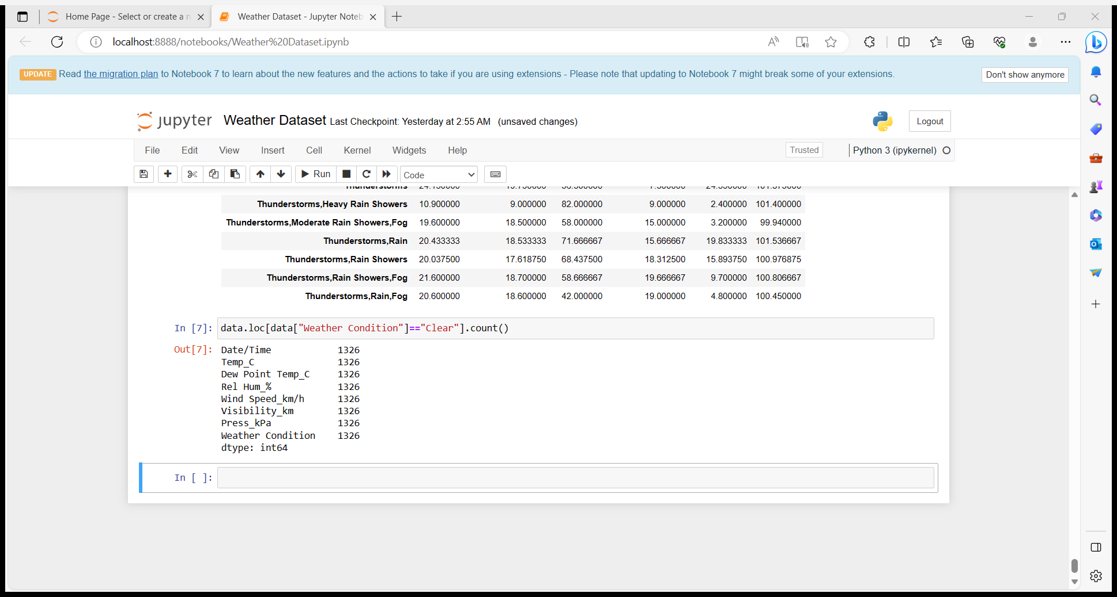

**Q. 3) Find the number of times when the 'Wind Speed was exactly 4 km/h'.**

Ans:- There are total 474 times the Wind Speed was exactly equal to 4 km/h.

Proof:-

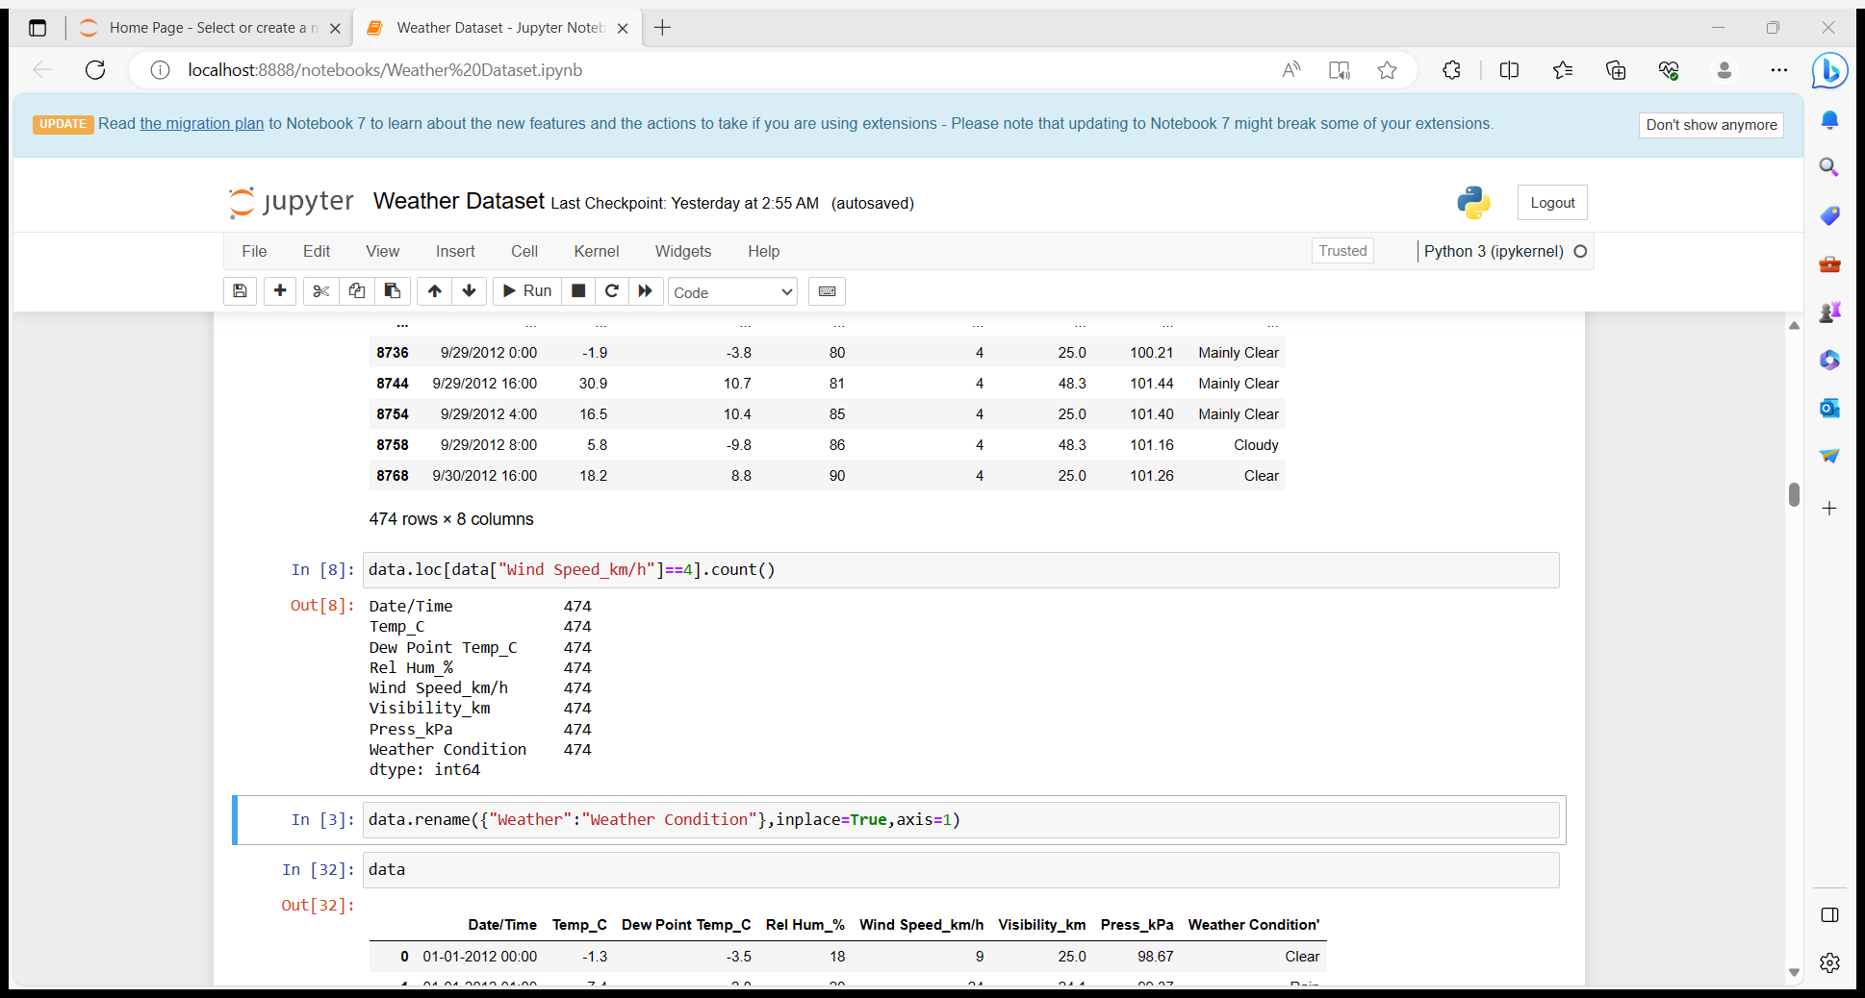

**Q. 4) Find out all the Null Values in the data.**

Ans:- There is no null values in the dataset.

Proof:-

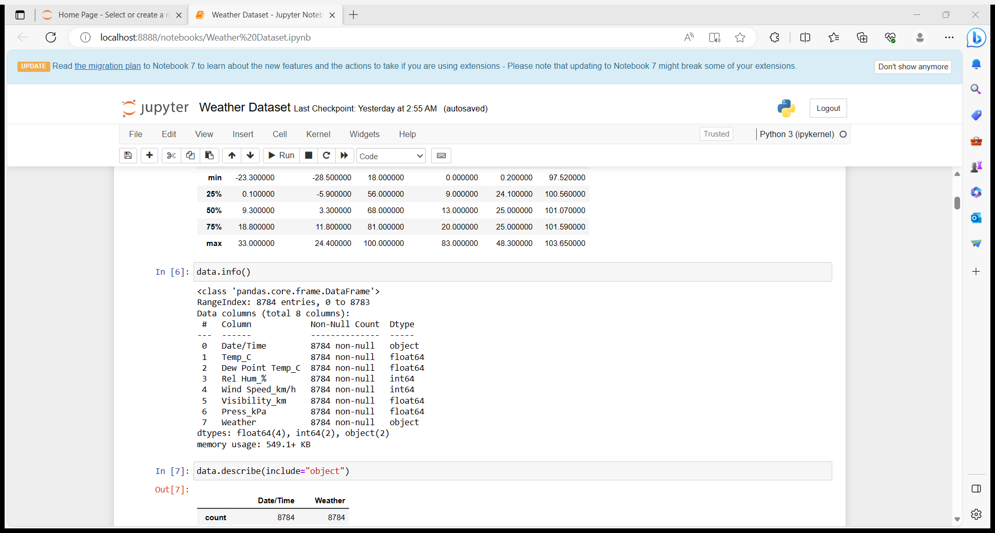

**Q. 5) Rename the column name 'Weather' of the dataframe to 'Weather Condition'.**

Ans:- By using rename function we can rename it and inside it we should use dictionary to change.

Proof:-

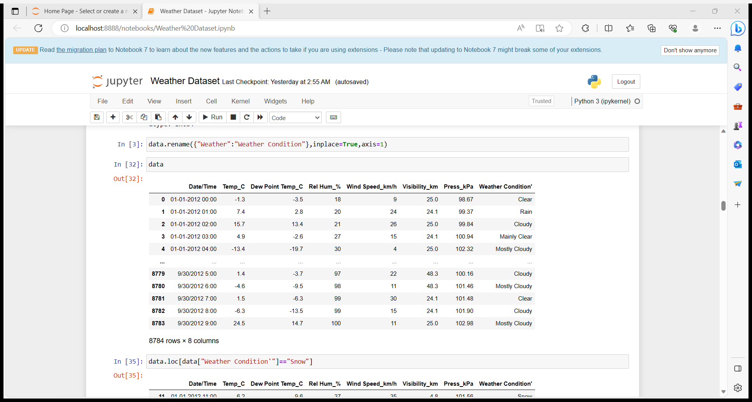

**Q. 6) What is the mean 'Visibility' ?**



Ans:- 27.66 is the mean value for Visibility. By using describe we came to know all these mean , minimum, maximum, count and std ,etc..,

Proof:-

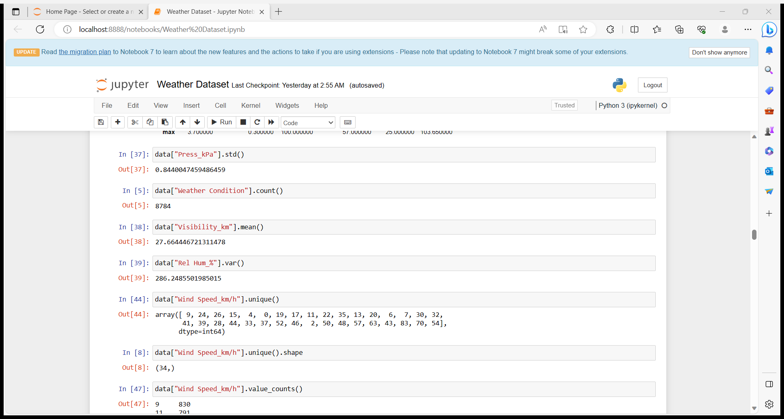

**Q. 7) What is the Standard Deviation of 'Pressure' in this data?**



Ans:- 0.84 is the std for the pressure in this data.

Proof:-

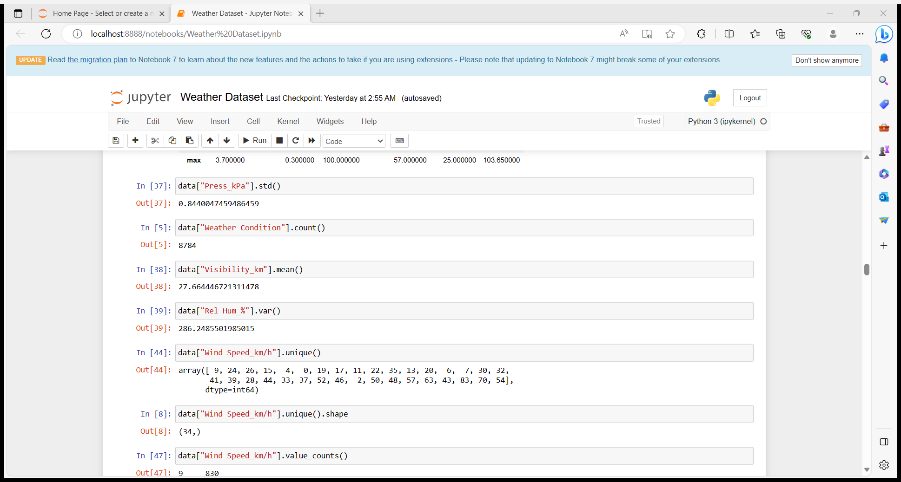

**Q. 8) What is the Variance of 'Relative Humidity' in this data ?**

Ans:- 286.24 is the variance for the relative humidity in this data.

Proof:-



**Q. 9) Find all instances when 'Snow' was recorded.**

Ans:- There are 390 instances where Snow was recorded in the data.

Proof:-

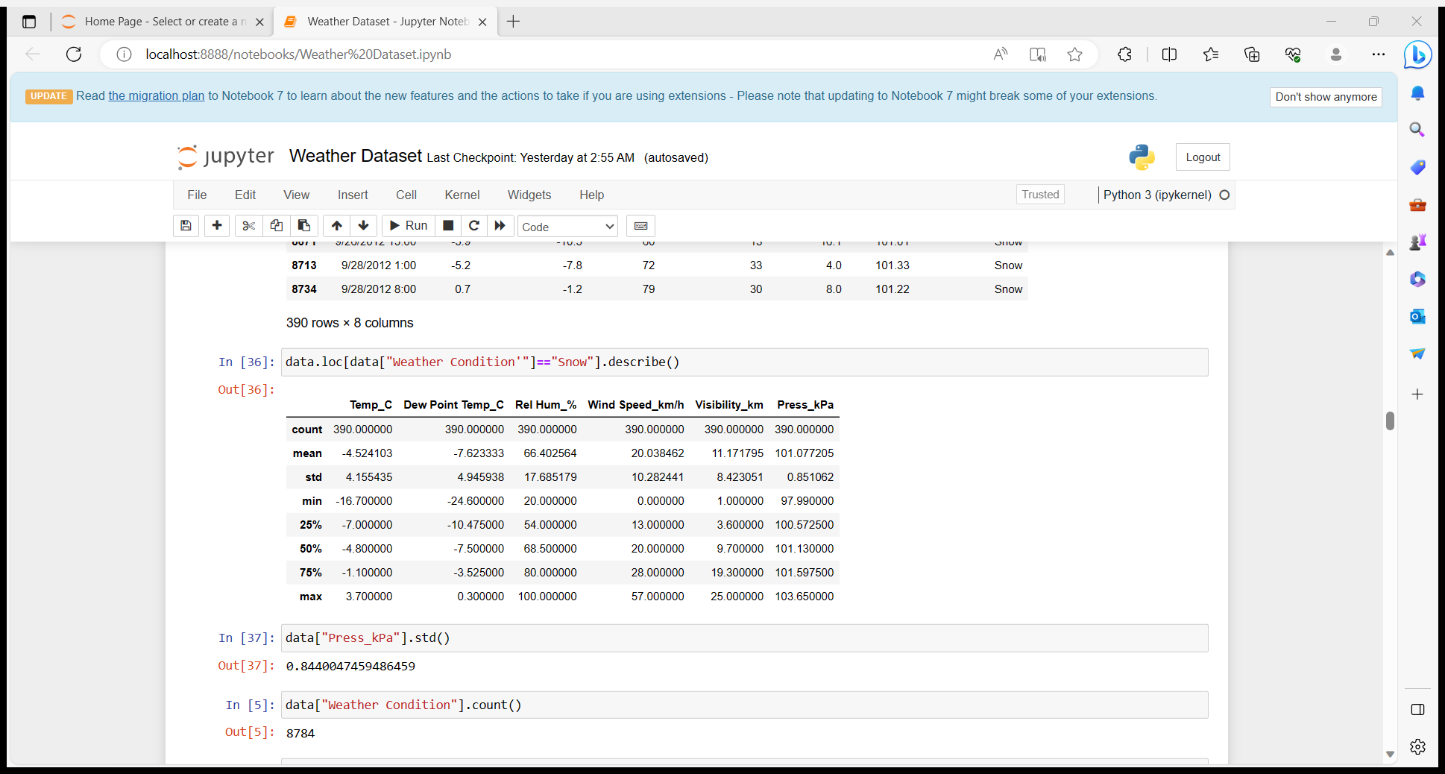

**Q. 10) Find all instances when 'Wind Speed is above 24' and 'Visibility is 25'.**

Ans:- There are 308 instances where wind speed is above 24 and visibility is 25.

Proof:-

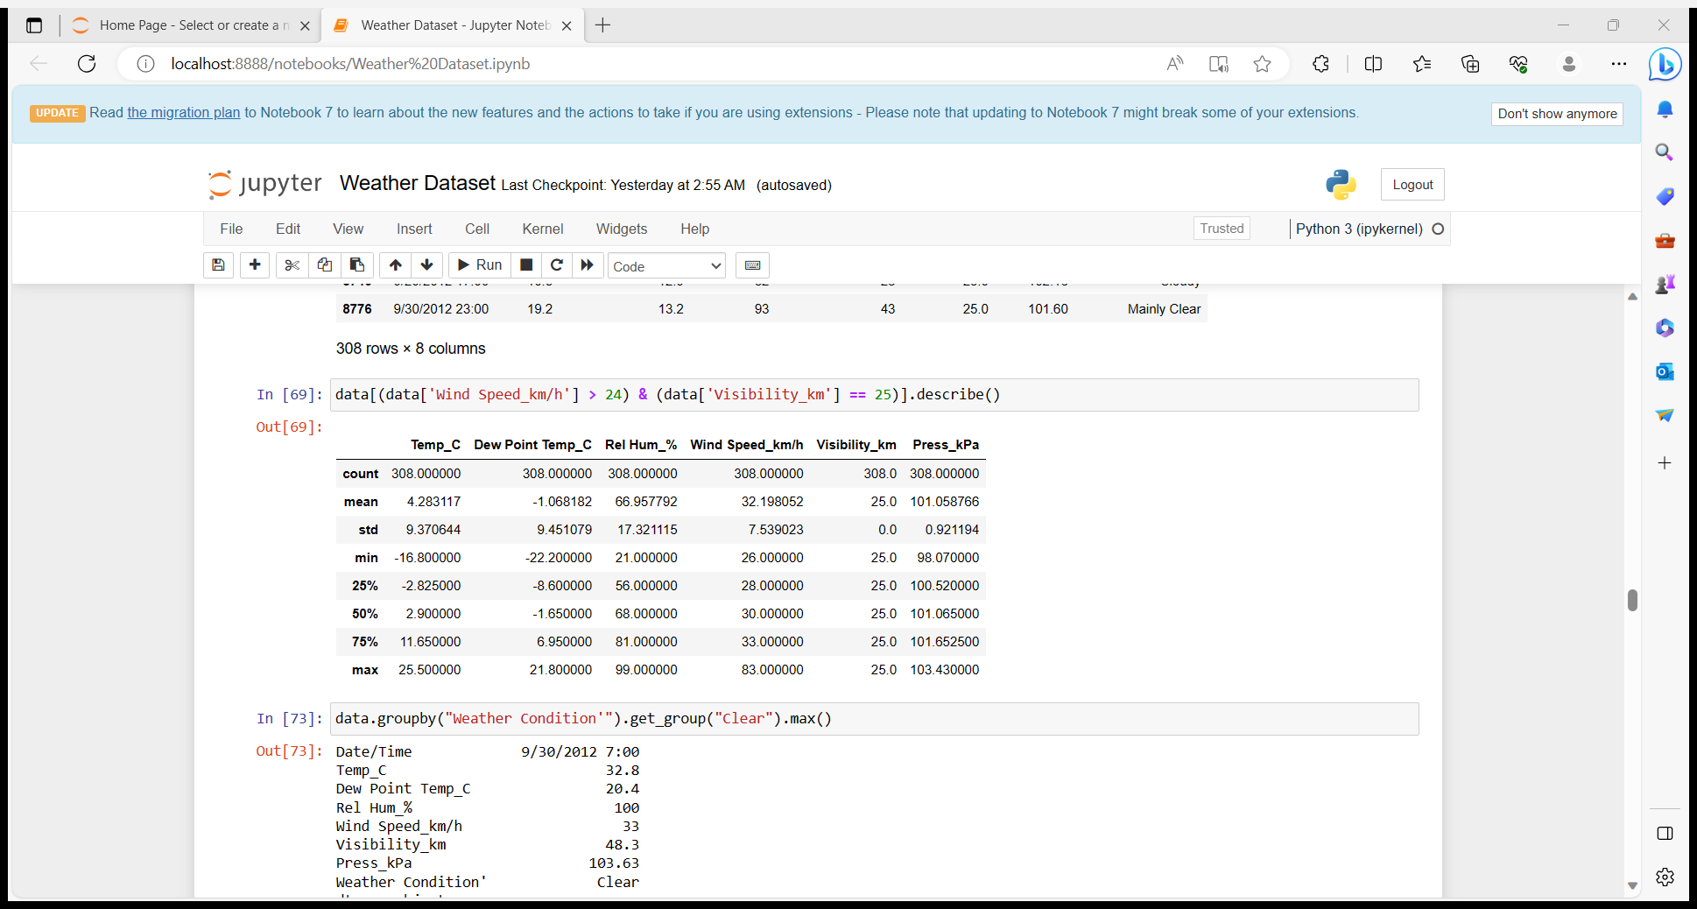

Q. 11) What is the Mean value of each column against each 'Weather Condition ?

Ans:- By using the below code we can know that the mean value for each coloum.

Proof:-

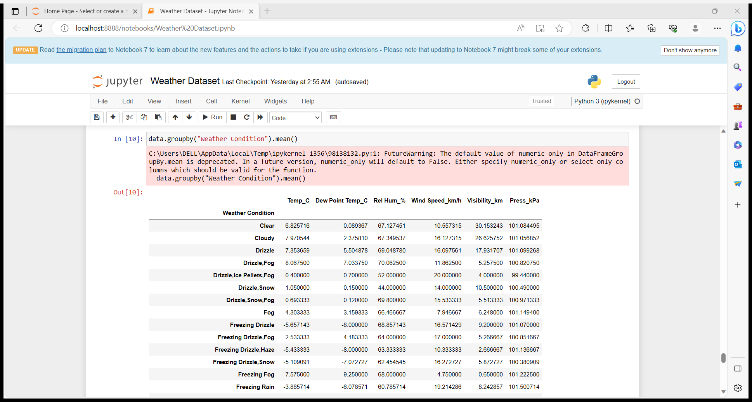

Q. 12) What is the Minimum & Maximum value of each column against each 'Weather Condition ?

Ans:-

Proof:-

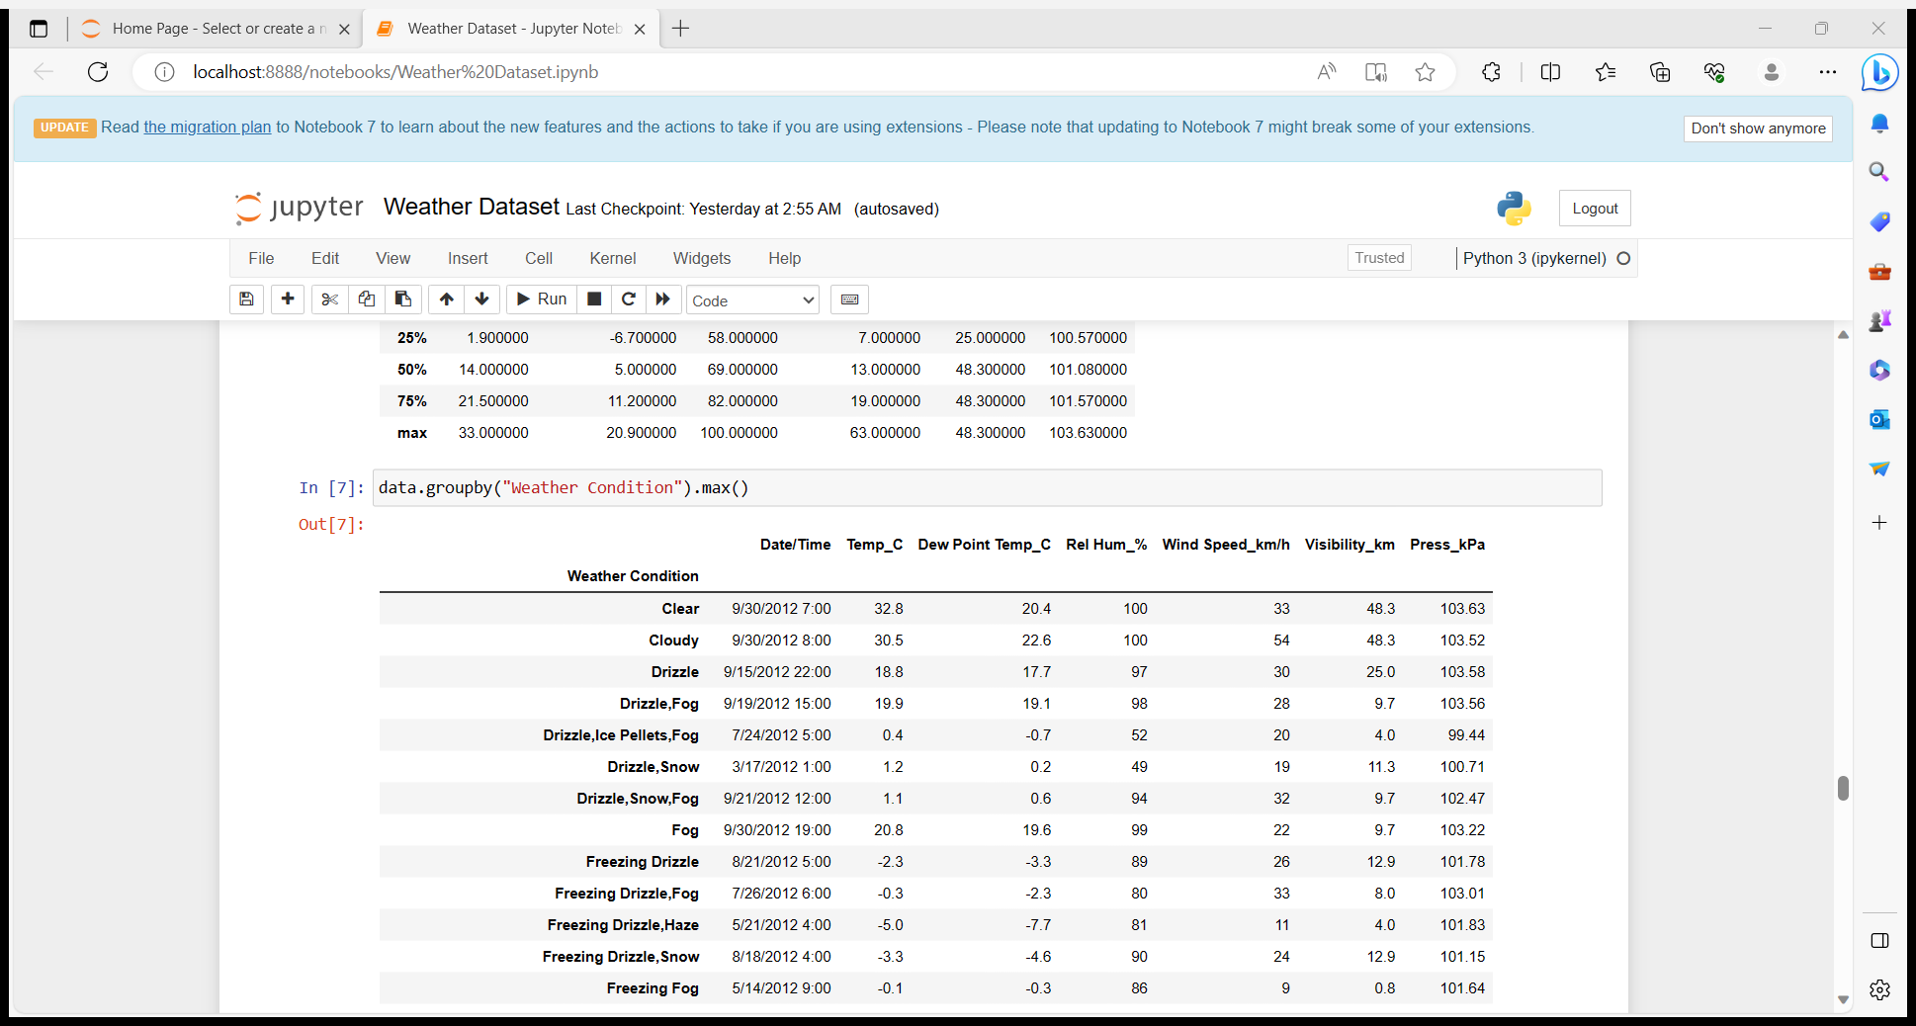

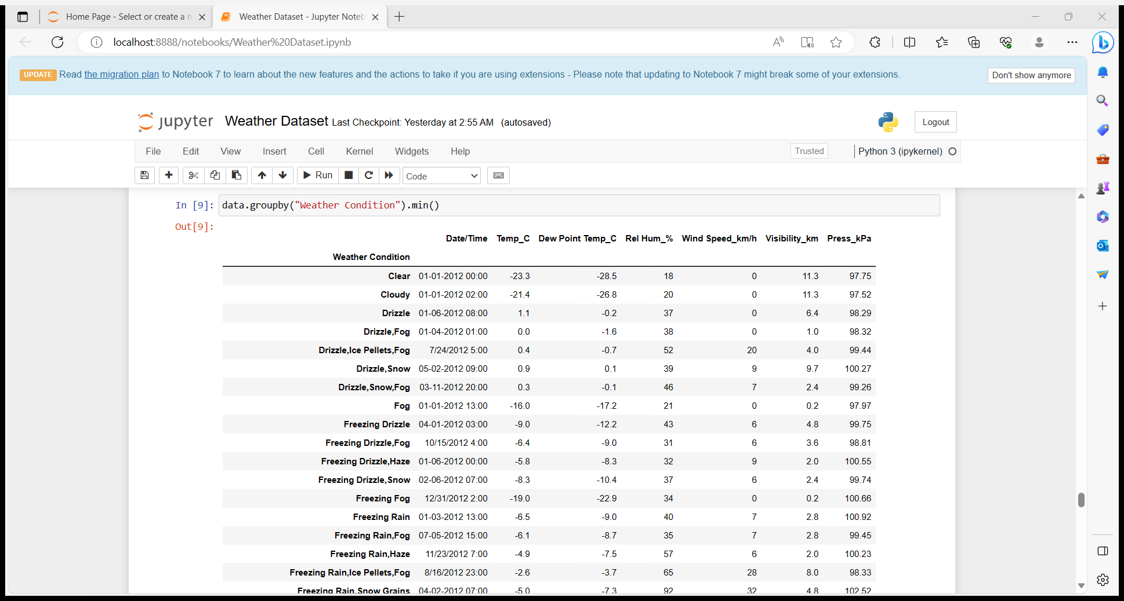

**Q. 13) Show all the Records where Weather Condition is Fog.**

Ans:- Total 150 times recorded where the Weather condition is Fog.

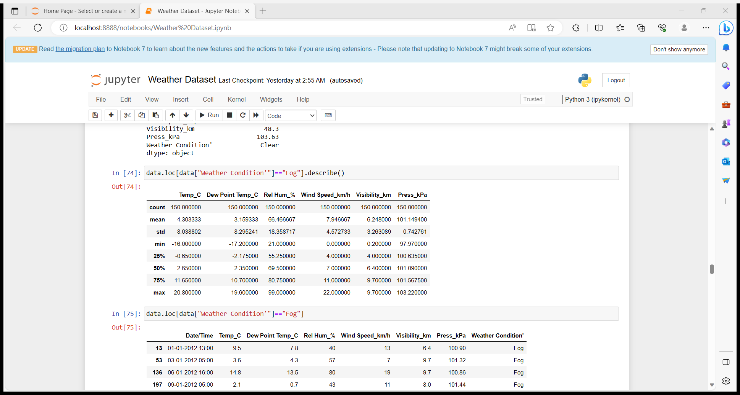

**Q. 14) Find all instances when 'Weather is Clear' or 'Visibility is above 40'.**

Ans:- Total 3027 items are there ,where the Weather condition is clear or visibility is above 40.

**Q. 15) Find all instances when :**

**A. 'Weather is Clear' and 'Relative Humidity is greater than 50'**

**or**

**B. 'Visibility is above 40'**

Ans:- Total 2864 items are there where the weather is clear and relative humidity is greater than 50 or the visibility is above 40.

Proof:- data[(data["Weather Condition'"] == "Clear") & (data["Rel Hum_%"] > 50) | (data["Visibility_km"] > 40)].describe()

|  |  |  |  |  |  |  |
| --- | --- | --- | --- | --- | --- | --- |
| **count** | 2864.000000 | 2864.000000 | 2864.000000 | 2864.000000 | 2864.000000 | 2864.000000 |

Thankyou